MAIN IDEA
Write the main idea of the story here.

PLOT
Retell the plot in a few sentences here.
BLURB
Write a blurb to “sell” your book here.

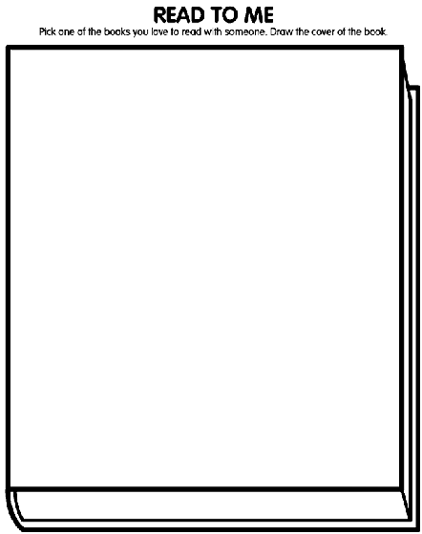
Draw or paste a picture of the book cover here.
Title:
Author:
BOOK
PROBLEM
Tell about the story’s main problem here.
CHARACTER
Describe your favorite character here.

SOLUTION
Tell how that problem was solved here.
SETTING
Describe a main place the story happens here.

PERSONAL RESPONSE
QUICKTAKES
Surprise
Emotion1215008






Recommendation
Connection

Rating

Vocabulary

