Resource #1 – Discovering Collection
http://asavagelibrarian.yolasite.com/
Go to Databases
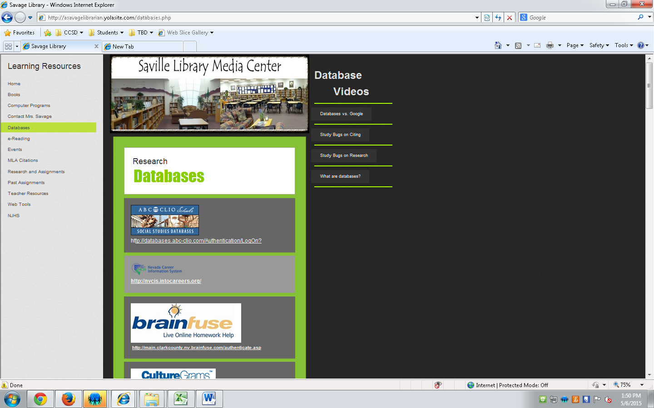
Select Gale
Select Discovering Collection
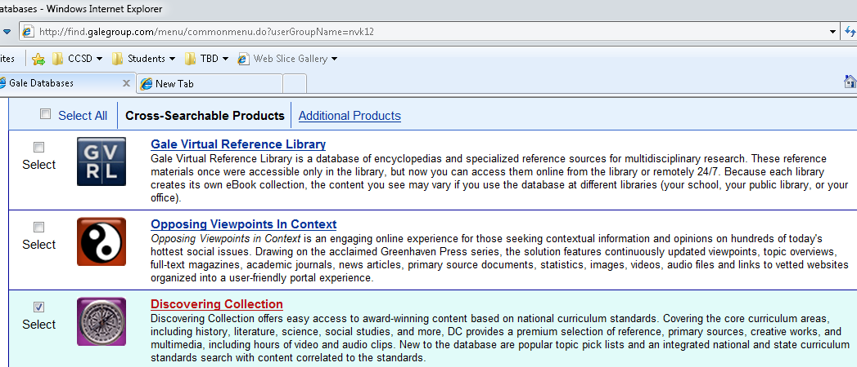

Select U.S. History
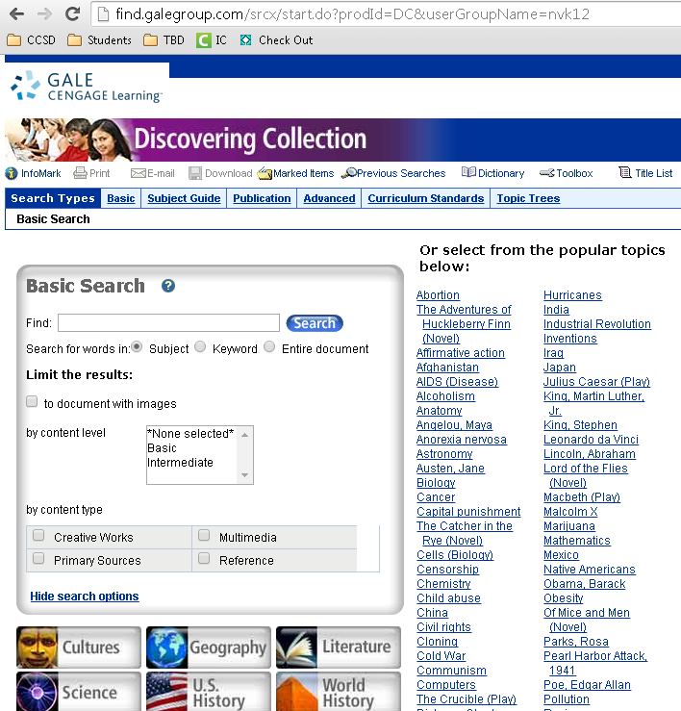
Search any history topic.

Resource #2 - Student Resources in Context
http://asavagelibrarian.yolasite.com/
Go to Databases
Select Gale
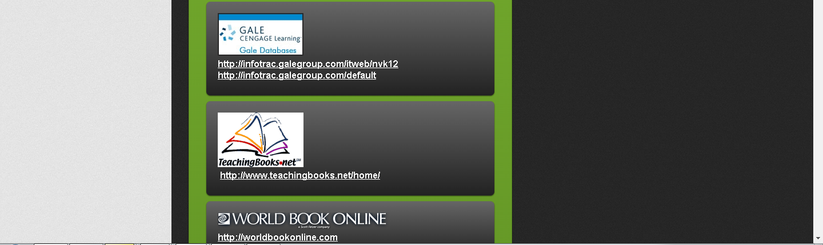
Select Student Resources in Context
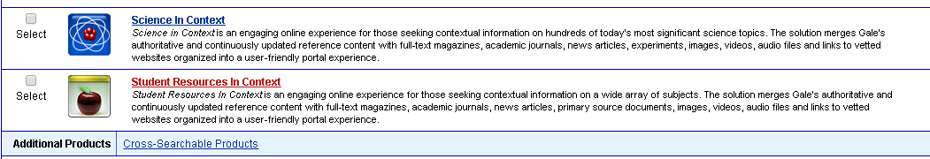

Search any topic or person
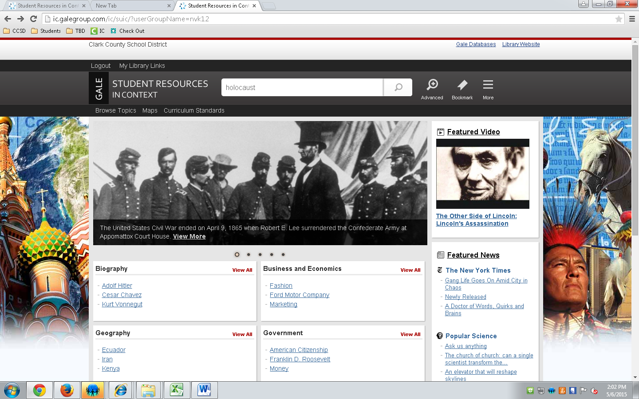
Resource #3 World Book Online Timelines
Create a Timeline Online by going to
http://asavagelibrarian.yolasite.com/
Go to Databases
Select World Book Online
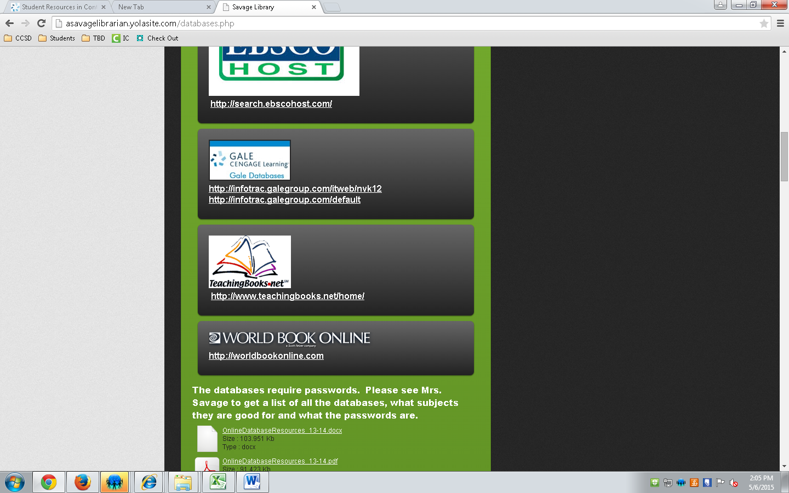
Select Timelines
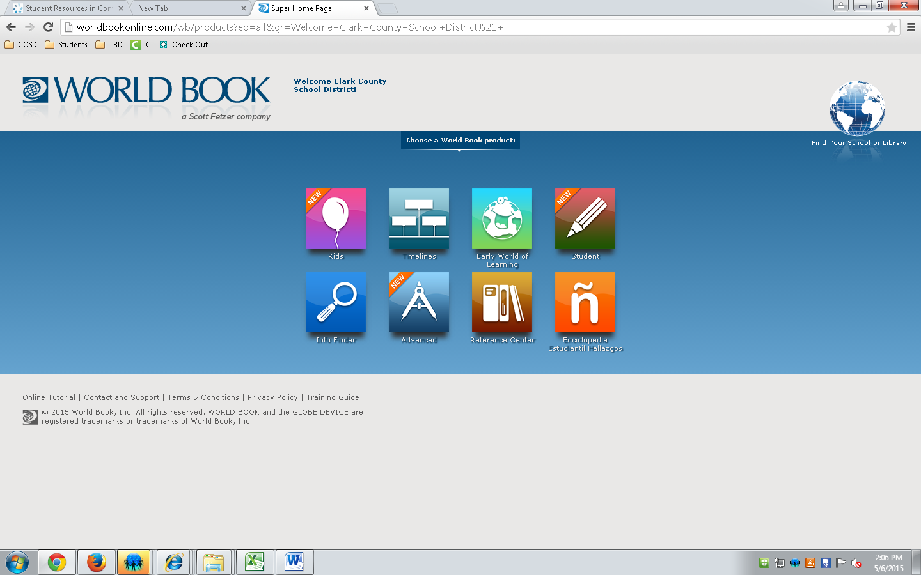
View a timeline or CREATE your own TIMELINE
