Free Online Access to Shakespeare http://worldbookonline.com/wb/products?ed=all&gr=Welcome+Clark+County+School+District%21+
username: ccsd2 password:
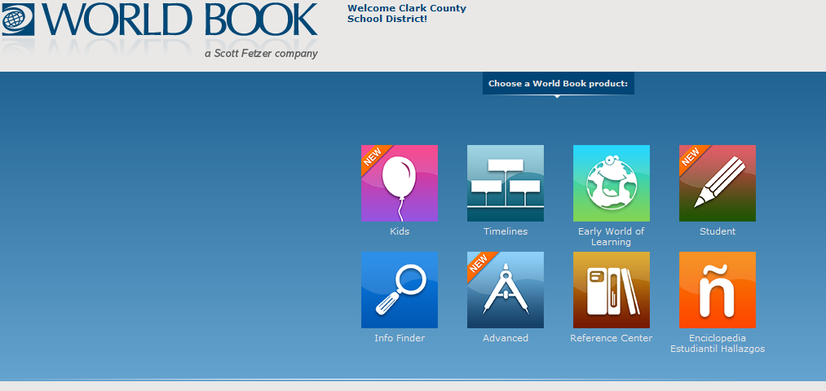
Select advanced
Select Online Book Archive 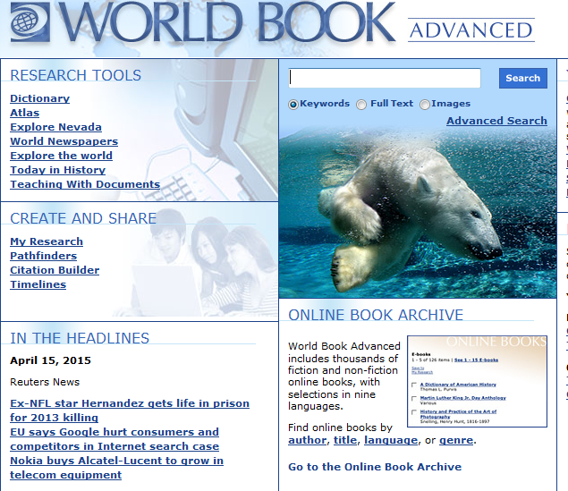
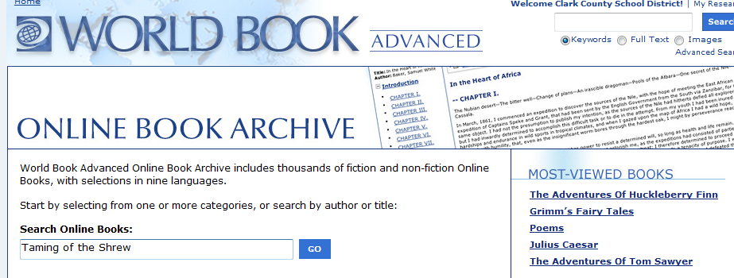

Type the title of the story you are looking for into the search field.
