Go to: http://asavagelibrarian.yolasite.com/pub8.php
Click on the World Book Advanced Button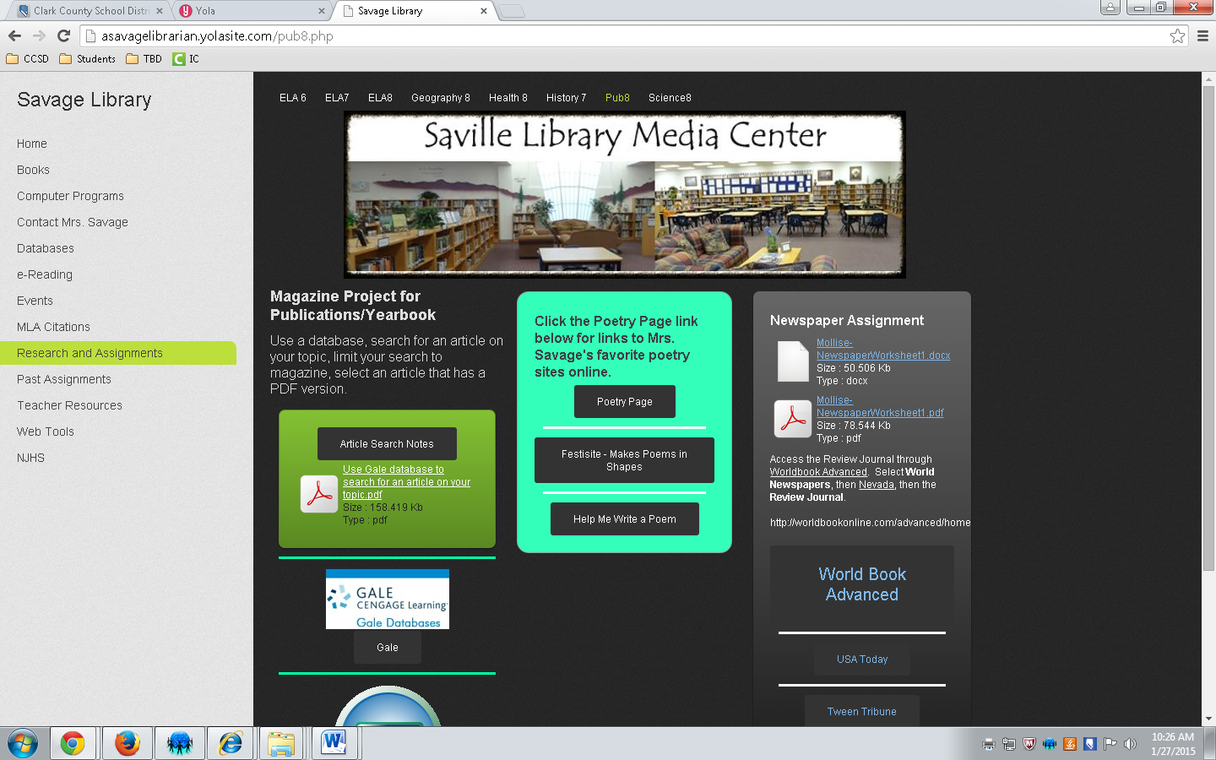
Select World Newspapers on the upper left hand portion of the screen. 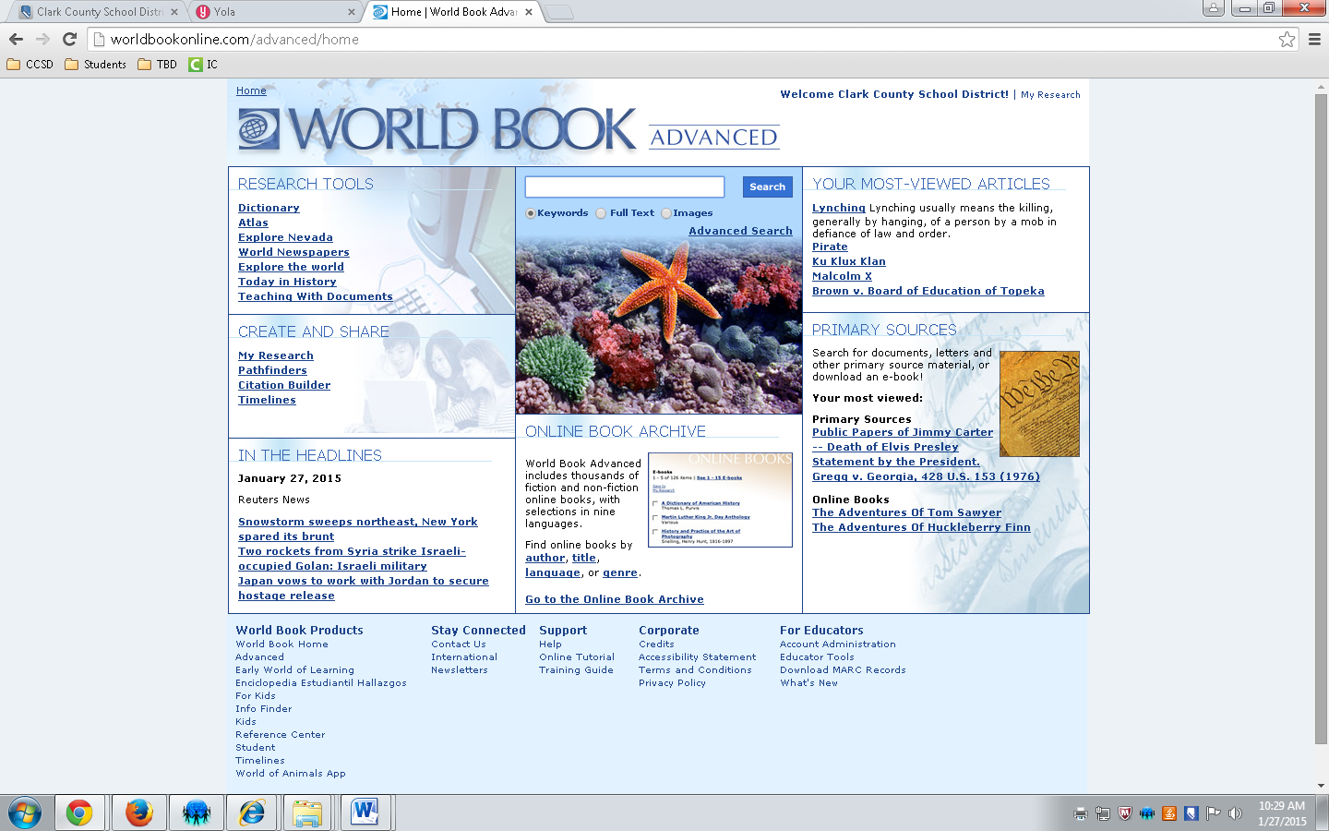
Select United States and Choose and State and then a Newspaper!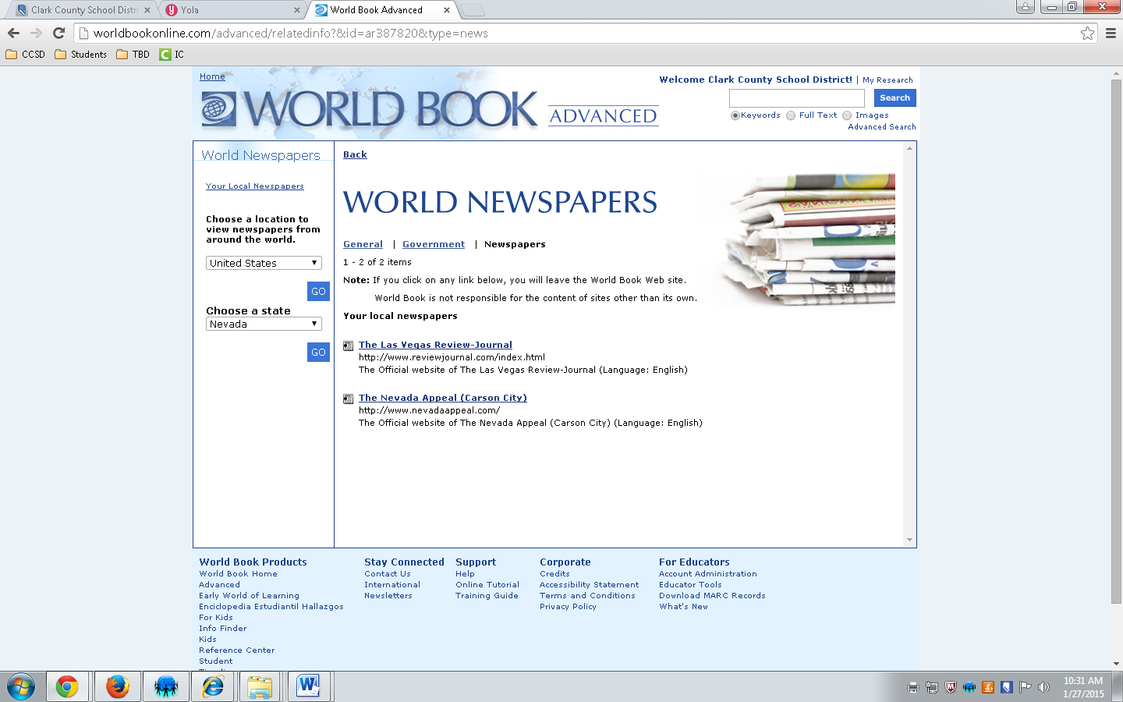
CITATION HELP @ Easybib.com Newspaper MANUAL CITE 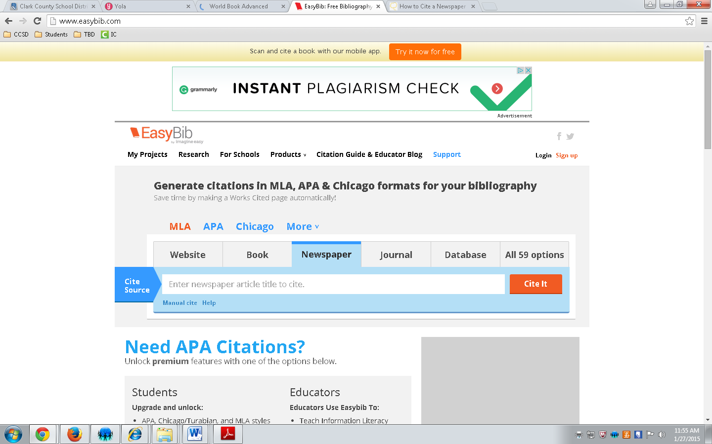
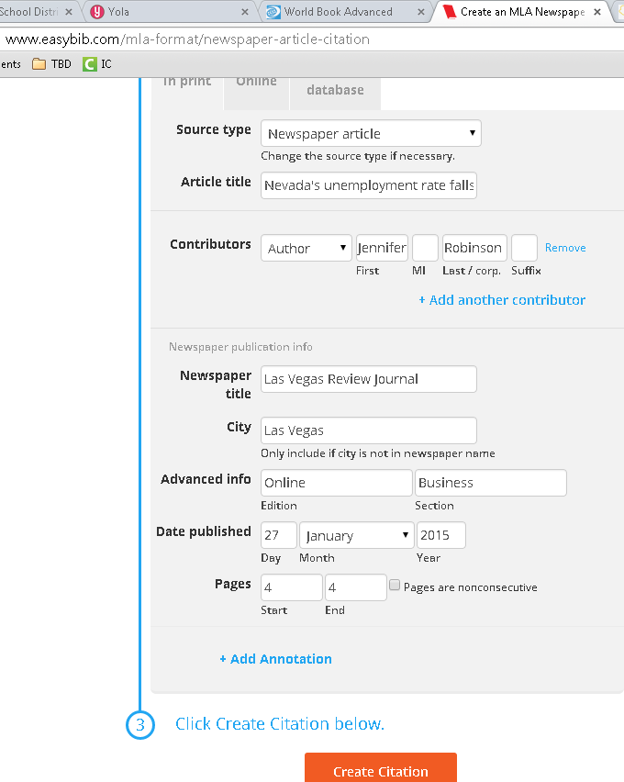
Fill out template with all the information that YOU can find. Hit create citation.
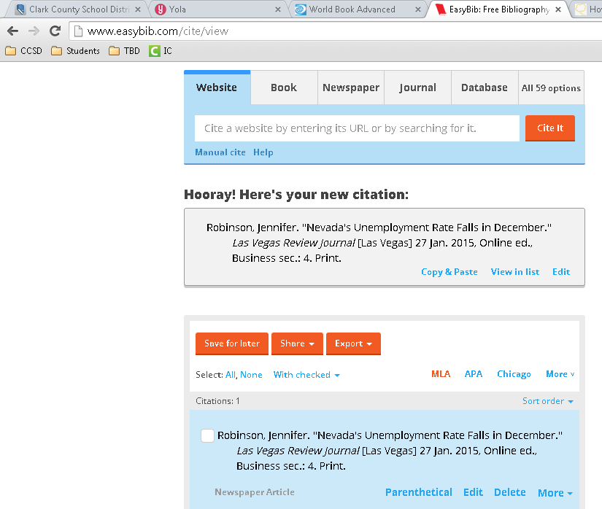
Copy and paste the citation into a Word document.

