My Side of the Mountain
Period 1
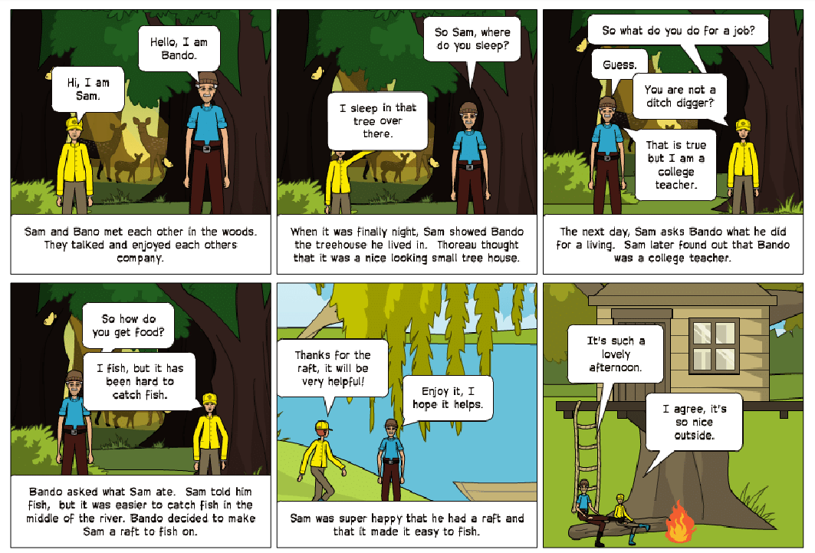
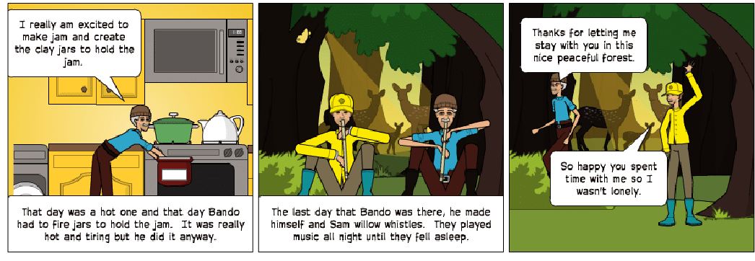
This part of the story is the portion where Sam meets a college teacher in New York named Bando.
The teacher stays in the woods with Sam for summer and helps Sam get food. He also helps Sam by making a fishing raft to use while fishing in the lake. Bando also made jars and jam for Sam. The jars weren’t made very well and the lids didn’t fit on the jars properly. Before Bando leaves, he tells Sam he would visit during Christmas break.

